PRG200 Week 3 Assignment Conditionals and Loops in Pythons

Jessica Gurung
Westcliff University
Professor Prakash
PRG200 Programming in Cloud
May 24, 2026

Question 1 : 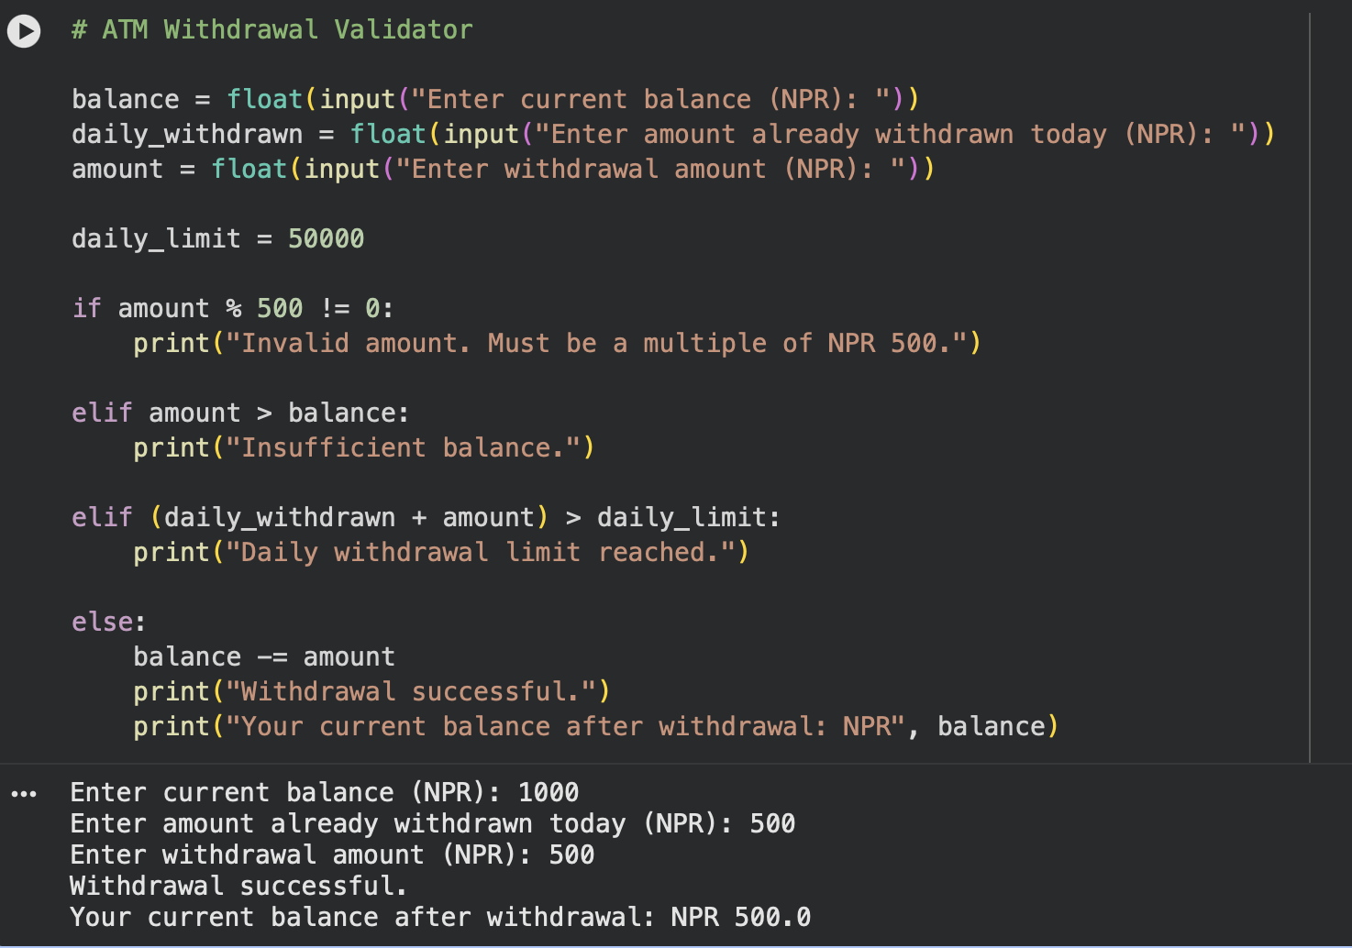

This program lets the customer know whether the computer will allow him or her to
withdraw funds from the ATM. It validates the amount to be withdrawn which must be in
multiples of NPR 500 also it also validates the balance of the account and ensures that the
amount to be withdrawn does not exceed the limit for a period of 1 day. If all conditions are true,
then the withdrawal is successful and the balance left is displayed.

Question 2: 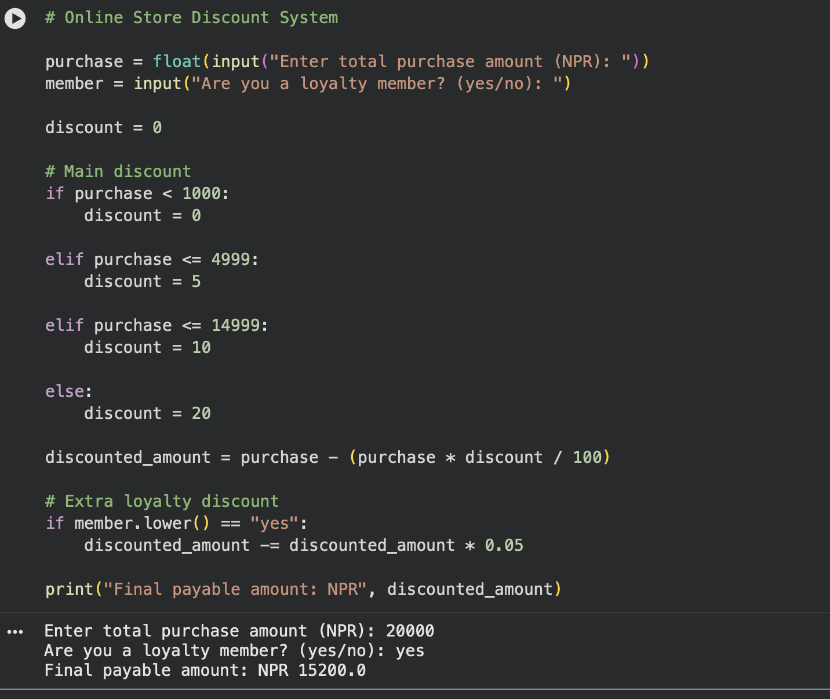

This program works out the total amount to pay after discounts based on the total amount
purchased by the customer. Various percentages of discount are given to varying price ranges.
Also, any loyalty members get an additional 5% discount on the discounted price. The program
has conditional statements to decide which discount to take and then use them to compute the
final price (Downey, 2024).

Question 3 : 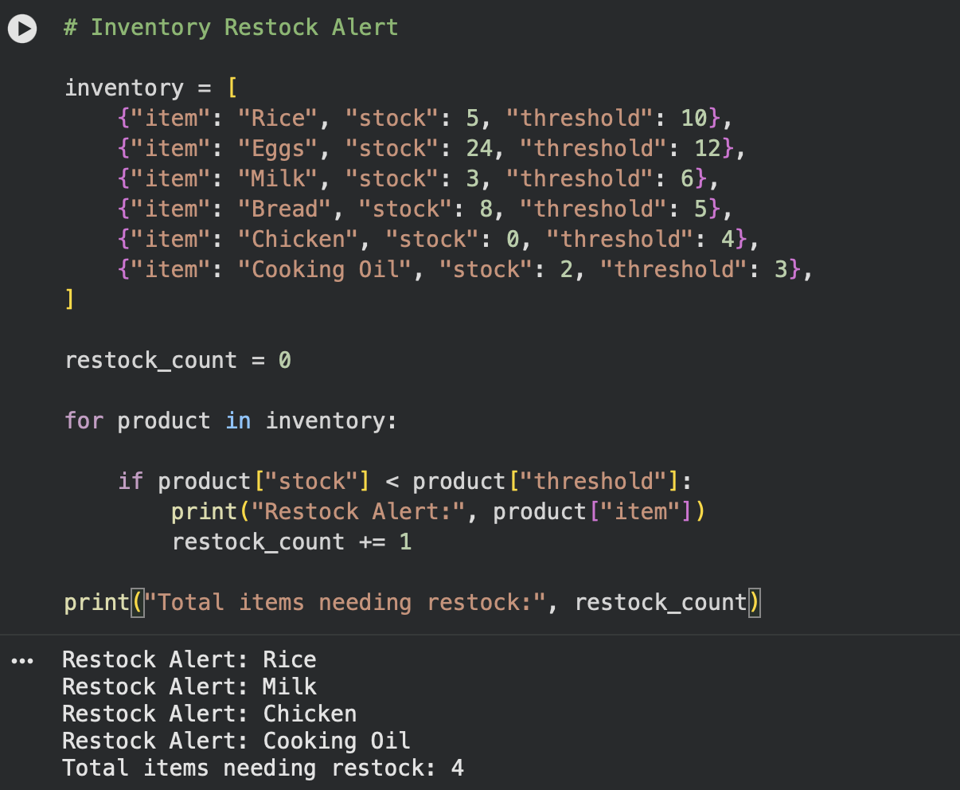

This program will track which products on the inventory must be replenished in a grocery
store. These items in the inventory list are sequentially accessed in a loop and then the value of
the stock is compared to the threshold value. When the stock is not above the set threshold, the
program will show a restock alert

Question 4 :
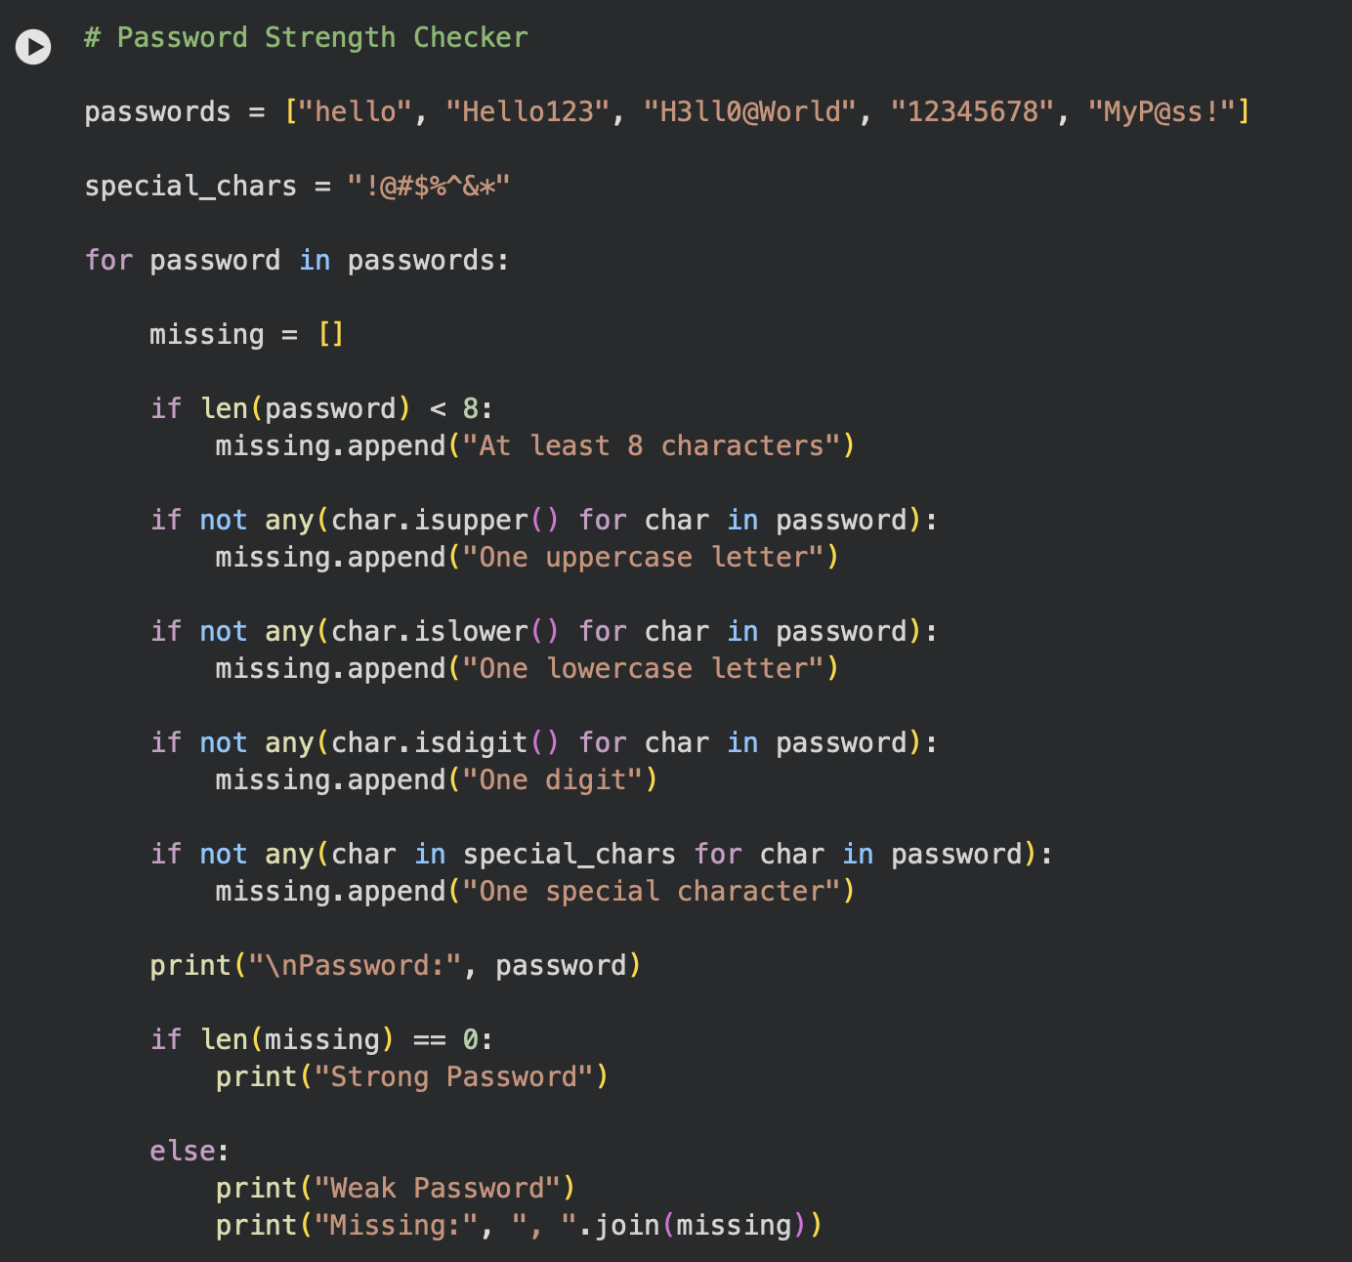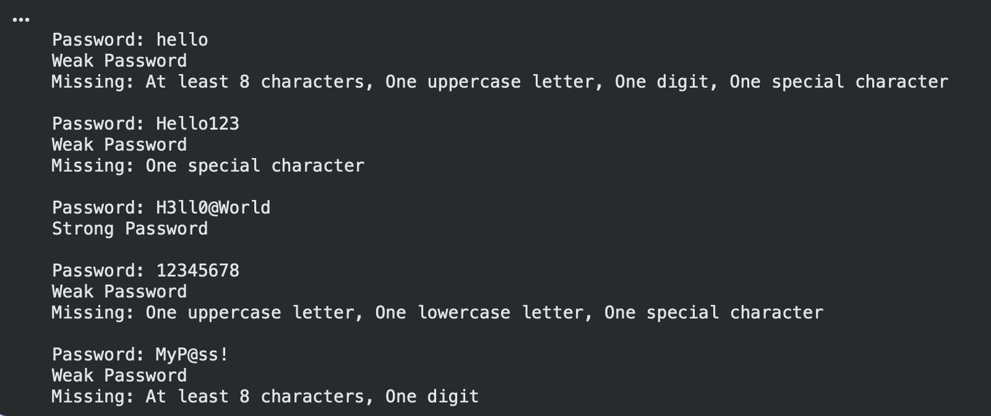
This program will check whether a password is secure or not based on some security
requirements. The program checks if the password has at least 8 characters, one uppercase letter,
one lowercase letter, one digit and one special character. A weak password is displayed with a
everything that its missing to indicate that it is strong if it not missing. The two password checks
are done in a loop and conditional statement.

Question 5 :
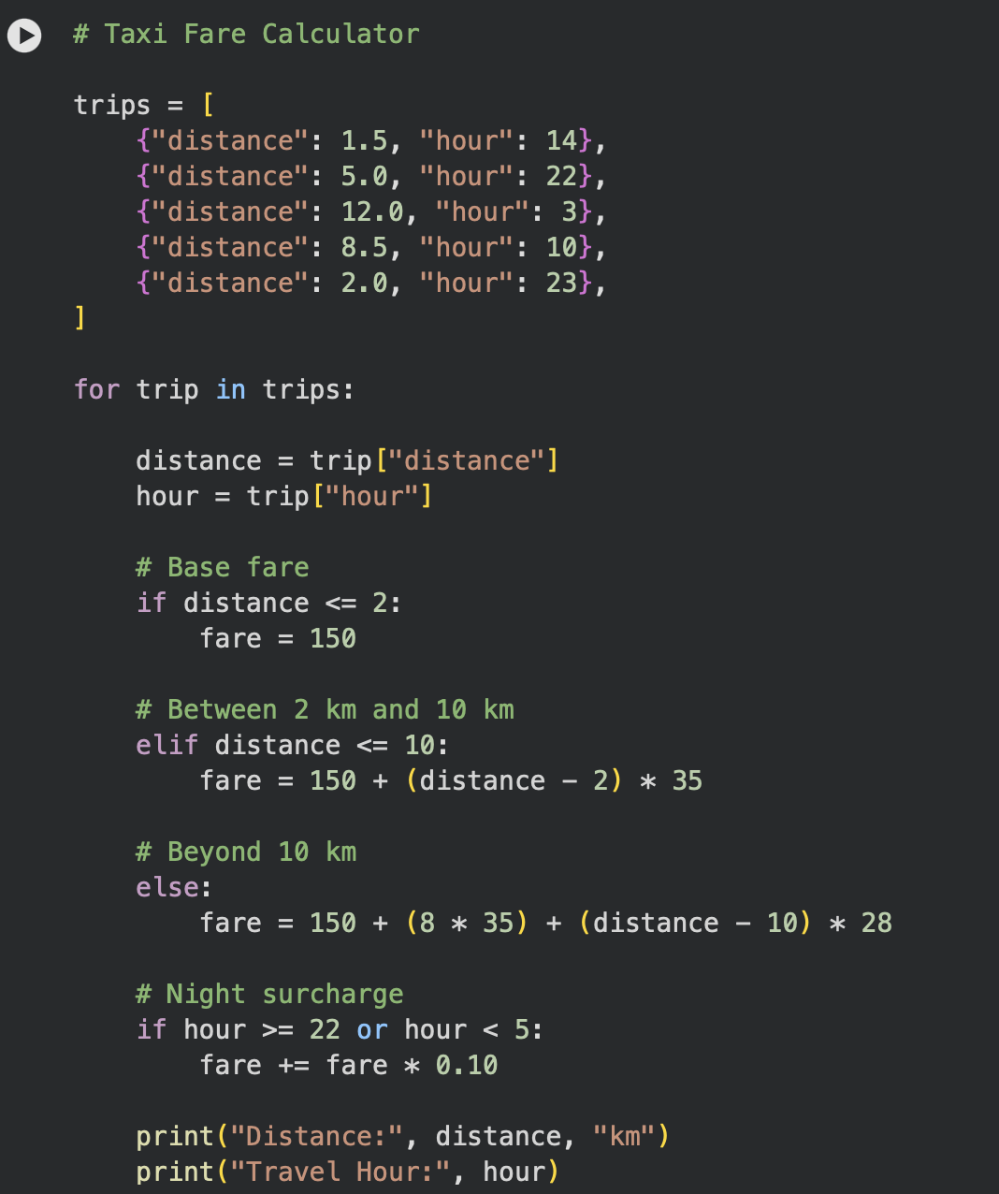

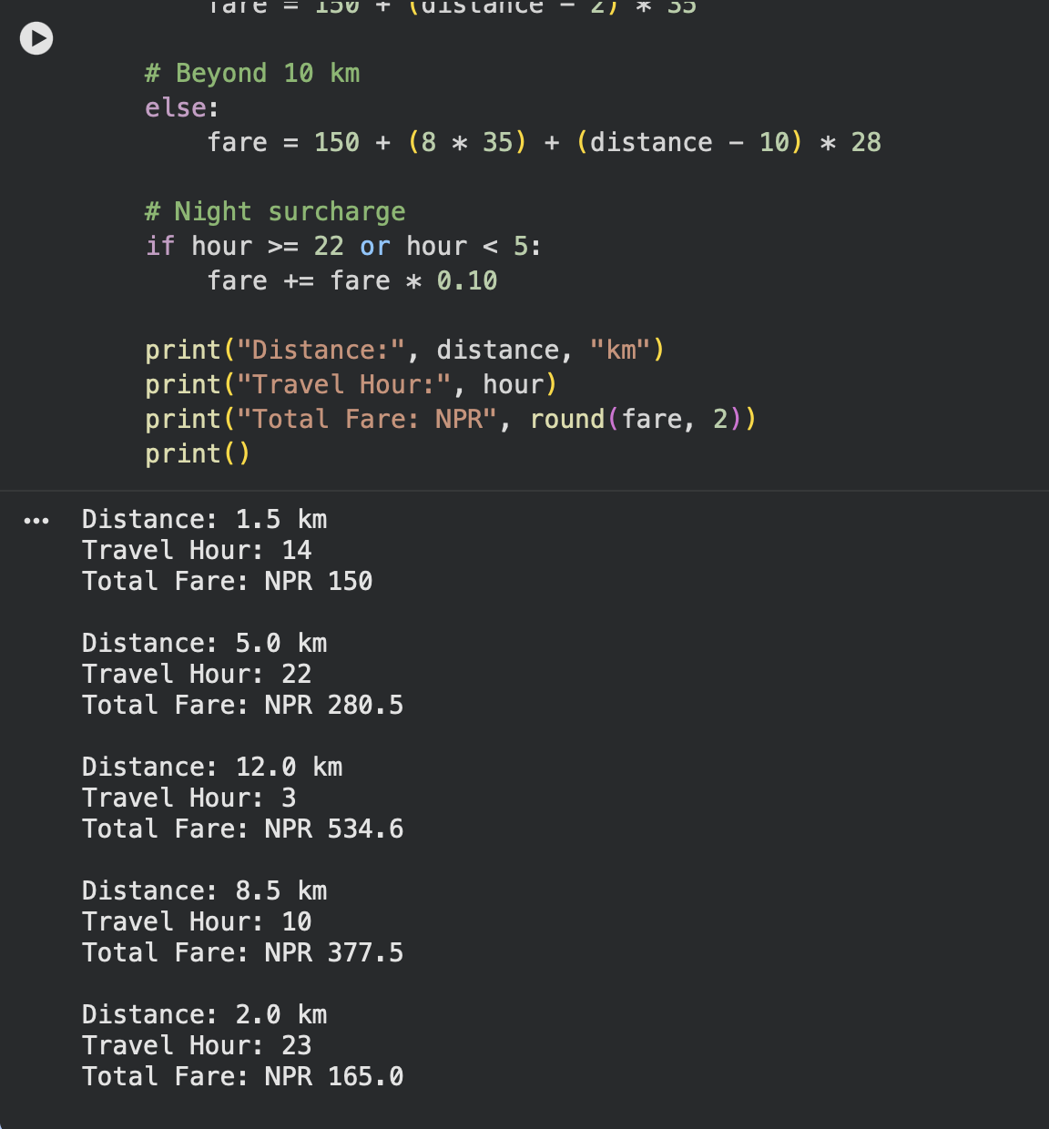

This program is a taxi fare calculation program that takes into account travel distance and
travel time. Fare is dependent on distance travelled. If the trip is in the night-time hours (between
10 PM and 5 AM) an extra 10% surcharge will be added to the total fare. The program has been
designed to be able to handle multiple trips and return the total cost for each trip.

References :
Python Software Foundation. (2024). Python documentation.
Downey, A. (2024). How to think like a computer scientist: Think Python. Think Python 3rd Edition by Allen B. Crawford and Margaret (Peg) H. Lewis

